How to use the Est. Ship Date report

- Log in to VendorNet

- Click on “Reports” and then “Est Ship Date”
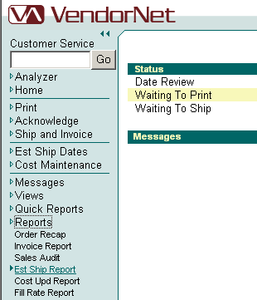

- You should receive a pop-up box labeled Report Selection Criteria
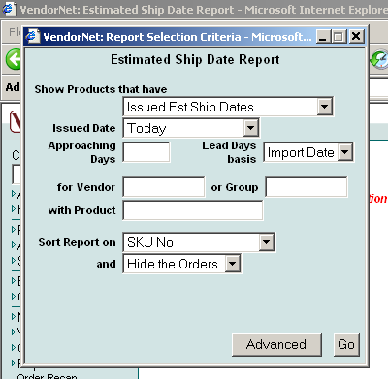

- Similar to the other Reports in VendorNet, the Estimated Ship Date report can be as general or specific as you want for your results. Your main options are to search by:
  - Pre-selected criteria via the “Show Products that have” field
  - Pre-selected date range via the “Issued Date” field
  - Vendor Number
  - Specific SKU
  - Orders

The following is a description of each of the options you have via the main Selection Criteria window:

Show Products that have: This allows the users to choose which orders will be included in the report based on an action that has or will occur on the order.

Available options are:

Issued Est Ship Dates: (default) This report lists all items/orders where an estimated ship date was entered or modified in the Estimated Ship Date function of VendorNet during the time frame selected.

Approaching Est Ship Dates: This report lists all items/orders that are expected to ship within the time frame selected based on the estimated ship date of the item or order.

Expired Est Ship Dates: This report lists all items/orders that have past their estimated ship date. It ignores the Issued Date and Approaching Days fields.

Expired Lead Days: This report lists all items/orders that have passed their lead days and have still not shipped. This is used if you are not using Est Ship Date in VendorNet and are simply relying on product or vendor lead days.

Expired Lead Days and Ship Dates: This report lists all items/orders that have passed their lead days and items/order that have passed their revised estimated ship date if one is assigned due to a delay indicated by the vendor.

Issued Date: This allows the user to include only orders that had an estimated ship date issued during a certain time frame. Only valid for the Issued Est Ship Dates report.

Available options are:

Cumulative to Date: all orders up to and including today
Today: orders from today only (default)
This Week To Date: orders from Sunday up to and including today
Last Week: orders from Sunday through Saturday of last week
This Month To Date: orders from the first day of the month up to and including today
Last Month: orders from the first day to the last day of the previous month
This Year To Date: orders from January 1 of the current calendar year through today

- Note: To select a custom date range, select the “Advanced” button after making all the selections on the current page

Approaching Days: Number of days before the estimated ship date. Only valid for the Approaching Est Ship Date Report.
Lead Days Basis: Determines when the calculation for lead days begins. Only valid for the Expired Ship Dates Report, and the Expired Lead Days and Ship Dates Report.

Available options are:

Import Date: (default) The number of days it takes to ship an order in VendorNet is calculated beginning the date the order was imported into VendorNet.
Print Date: The number of days it takes to ship an order in VendorNet is calculated beginning the date the order was printed in VendorNet.

For vendor: Enter a vendor number here to subset the report results by selecting a single vendor.

Or group: Enter a group number here to subset the report results by selecting a group.

With Product: Enter a product number (vendor assigned number or advertised SKU) here to subset the report results by selecting only orders that contain that product number.

Please note: In the “Sort Report on” field, select either “Order No” or “Vendor No/Order No”. Do not use any of the options involving the SKU. Our current version of VendorNet does not support those searches. You may, however, use the “With Product” field if there is a particular SKU you wish to view.

- When your selections have been made, click “Go” to run the report. If you wish to narrow your search further, click on “Advanced” to access the next Criteria window.

- After you click “Go”, the selection criteria box should minimize and the VendorNet screen should be updated with the requested information. If you should need to revise your search, click on the additional “VendorNet” window to maximize the Criteria box again.

